Tyrion:Users:MAN:Desktop:SGA:LA Housing:Letterhead:Round 2:Finals:LA_HCID_Letterhead_FINAL_Blank.pdf

PV Home

Center Pointe Club

6200 Playa Vista Drive

Playa Vista, CA 90094

Attn: PV Home Administrator

**RE: Controlled Price Unit Resale Notification**

To Whom It May Concern:

I \_\_\_\_\_\_\_\_\_\_\_\_\_\_\_\_\_\_\_\_\_\_\_\_\_\_\_\_\_\_\_\_\_\_\_\_\_\_\_\_\_, the owner of unit \_\_\_\_\_\_\_\_\_\_, located at \_\_\_\_\_\_\_\_\_\_\_\_\_\_\_\_\_\_\_\_\_\_\_\_\_\_\_\_\_\_\_\_\_\_\_\_\_\_\_\_\_\_\_\_\_ address of the Playa Vista development in the City of Los Angeles hereby gives notice to PV Home of my intent to sale the unit listed above. I can be reached at \_\_\_\_\_\_\_\_\_\_\_\_\_\_\_\_\_\_\_\_\_\_\_\_\_ (phone number) or at \_\_\_\_\_\_\_\_\_\_\_\_\_\_\_\_\_\_\_\_\_\_\_\_\_\_\_\_\_\_\_\_\_\_\_\_\_\_\_\_\_\_\_\_\_\_\_\_\_\_\_ (address). I will be in contact with the Center Pointe Club to request a price calculation before entering into any agreements with prospective buyers.

Sincerely,

\_\_\_\_\_\_\_\_\_\_\_\_\_\_\_\_\_\_\_\_\_\_\_\_\_\_\_\_\_\_\_\_\_\_\_\_\_\_\_\_\_\_\_\_\_\_\_\_\_\_

(Signature)

Mail to:

City of Los Angeles

Los Angeles Housing + Community Investment Department

1200 West 7th Street, 8th Floor

Los Angeles, California 90017

Attn: Environmental and Land Use Services Unit

Tyrion:Users:MAN:Desktop:SGA:LA Housing:Letterhead:Round 2:Finals:LA_HCID_Letterhead_FINAL_Blank.pdf

**RECORDING REQUEST BY:**

**AND WHEN RECORDED MAIL TO:**

PV Home

Center Pointe Club

6200 Playa Vista Drive

PLAYA VISTA, CALIFORNIA 90094

ATTENTION: PV Home Administrator

-----------------------SPACE ABOVE THIS LINE FOR RECORDER’S USE-----------------------

CITY OF LOS ANGELES AGREEMENT NUMBER \_\_\_\_\_\_\_\_\_\_\_\_\_\_\_\_

**OPTION TO PURCHASE AGREEMENT**

This Option to Purchase Agreement (the "Option Agreement") is entered into as of this \_\_\_\_\_ day of \_\_\_\_\_\_\_\_\_\_\_\_\_\_\_\_\_\_\_\_, 20\_\_, by and between the City of Los Angeles (the "City"), acting by and through the City of Los Angeles Housing + Community Investment Department (the "Department"), and \_\_\_\_\_\_\_\_\_\_\_\_\_\_\_\_\_\_\_\_\_\_\_\_\_\_\_\_\_\_\_\_\_\_\_\_\_ (the "Owner"). Unless otherwise defined herein, all capitalized terms shall have the meaning accorded those terms in that certain Agreement Containing Covenants Affecting Real Property (Controlled Price Units) between the City and Maguire Thomas Partners Playa Vista ("MTP PV") dated as of 1996 (the "Controlled Price Agreement").

**RECITALS**

WHEREAS, the Controlled Price Agreement specifies that MTP PV shall provide a certain number of Controlled Price Units as part of the first phase of development of the Playa Vista Property;

WHEREAS, all Controlled Price Units are subject to the provisions of the Controlled Price Agreement;

WHEREAS, Owner is the Buyer of a Controlled Price Unit, the legal description of which is set forth on Exhibit A attached hereto; and

WHEREAS, the City desires to ensure that if Owner's Controlled Price Unit is potentially subject to foreclosure proceedings, the City will have an opportunity to receive notice of such foreclosure and an opportunity to acquire such Unit prior to a foreclosure sale.

NOW THEREFORE, in consideration of the mutual covenants and representations contained herein, the parties hereto covenant, represent and agree as follows:

**AGREEMENT**

1. Purchase Option. Owner hereby grants to the City an option to purchase Owner's Controlled Price Unit (the "Purchase Option") on the terms of this Option Agreement. The City may designate a governmental or nonprofit organization to exercise the Purchase Option. After the exercise of the Purchase Option in the manner hereinafter prescribed, the City or its designee may assign the Purchase Option to any substitute individual private buyer, provided, however, that such subsequent assignment shall not extend any time limits contained herein. The City shall give the Owner notice of any designation or assignment pursuant to this Section 1.

2. Default and Foreclosure.

(a) A request for notice of default or notice of sale under any deed of trust or mortgage with power of sale encumbering Owner's Controlled Price Unit shall be recorded by the City or its designee. Upon City's receipt of such notice, City may exercise its Purchase Option pursuant to the provisions of this Option Agreement; provided, however, that notwithstanding any language contained in this Option Agreement to the contrary, with regard to the rights of the lien holder, City must complete such purchase no later than the end of the period established by California Civil Code Section 2924c for reinstatement of a monetary default under the deed of trust or mortgage.

(b) In the event of default and foreclosure, City shall have the same right as Owner to cure defaults and redeem the Controlled Price Unit prior to foreclosure sale. Such redemption shall be subject to the same fees, charges and penalties which would otherwise be assessed against the Owner. Nothing herein shall be construed as creating any obligation on the part of the City to cure any such default, nor shall this right to cure and redeem operate to extend any time limitations in the default provisions of the underlying deed of trust or mortgage.

(c) In the event the request for notice is recorded, City's Purchase Option shall run from the date the notice of default is given to the Owner, and any such purchase must be completed within the period established in this Section 2.

(d) In the event that City elects not to exercise its rights to purchase upon default, and a foreclosure sale is consummated, any party, and its successors 'and assigns, receiving title to the Controlled Price Unit through a trustee's sale, a judicial foreclosure sale or deed in lieu of foreclosure, or through any conveyance or transfer thereafter, shall receive title free and clear of the provisions of this Option Agreement.

3. Notices. All notices required herein shall be in writing and shall be considered as given when personally delivered or one business day following the day on which notice is delivered to Federal Express or similar overnight delivery service with all delivery charges paid, addressed to the parties as follows:

If to City: City of Los Angeles

Los Angeles Housing + Community Investment Department

1200 West 7th Street, 8th Floor

Los Angeles, California 90017

Attention: Environmental and Land Use Services Unit

If to Owner: \_\_\_\_\_\_\_\_\_\_\_\_\_\_\_\_\_\_\_\_\_\_\_\_\_\_\_\_\_\_\_\_\_\_\_\_\_\_\_

\_\_\_\_\_\_\_\_\_\_\_\_\_\_\_\_\_\_\_\_\_\_\_\_\_\_\_\_\_\_\_\_\_\_\_\_\_\_\_

\_\_\_\_\_\_\_\_\_\_\_\_\_\_\_\_\_\_\_\_\_\_\_\_\_\_\_\_\_\_\_\_\_\_\_\_\_\_\_

The address of a party for notices may be changed by that party's designation to all other parties of the new address and the recording of the designation, including the recording reference of this Option Agreement and the legal description of Owner's Controlled Price Unit attached as Exhibit A.

4. Benefits and Burdens. All provisions of this Option Agreement, including the benefits and burdens, run with the land described in Exhibit A and are binding upon the heirs, successors, assigns and personal representatives of the parties hereto and inure to the benefit of the heirs, personal representatives and permitted successors and assigns of the parties hereto.

5. Termination. This Option Agreement shall terminate on the earlier of (i) conveyance to the City or its designee pursuant to exercise of the Purchase Option, (ii) acquisition of title through a foreclosure of any consensual lien to which this Option Agreement has been subordinated or (iii) termination of the Controlled Price Agreement pursuant to the terms thereof. Upon termination of this Option Agreement, on request of the then record owner of the fee title to the Controlled Price Unit, the City shall execute, acknowledge and record a termination of this Option Agreement.

IN WITNESS WHEREOF, the City, acting by and through the Department, and Owner has caused this Option Agreement to be executed by their duly authorized representatives.

|  |  |  |
| --- | --- | --- |
| APPROVED AS TO FORM:  MICHAEL N. FEUER, City Attorney  By: \_\_\_\_\_\_\_\_\_\_\_\_\_\_\_\_\_\_\_\_\_\_\_\_\_\_\_\_\_\_  Deputy City Attorney  Date: \_\_\_\_\_\_\_\_\_\_\_\_\_\_\_\_\_\_\_\_  ATTEST:  HOLLY WOLCOTT, City Clerk  By: \_\_\_\_\_\_\_\_\_\_\_\_\_\_\_\_\_\_\_\_\_\_\_\_\_\_\_\_\_\_\_  Deputy City Clerk  Date: \_\_\_\_\_\_\_\_\_\_\_\_\_\_\_\_\_\_\_  By: \_\_\_\_\_\_\_\_\_\_\_\_\_\_\_\_\_\_\_\_\_\_\_\_\_\_\_\_\_\_\_  Owner  Date: \_\_\_\_\_\_\_\_\_\_\_\_\_\_\_\_\_\_\_ |  | Executed this \_\_\_\_\_\_\_\_\_ day of  \_\_\_\_\_\_\_\_\_\_\_\_\_\_\_\_\_\_\_\_\_\_\_\_\_\_\_, 20\_\_  For: **THE CITY OF LOS ANGELES**    **RUSHMORE D. CERVANTES**  General Manager  Los Angeles Housing + Community Investment Department  By\_\_\_\_\_\_\_\_\_\_\_\_\_\_\_\_\_\_\_\_\_\_\_\_\_\_\_\_\_\_  HELMI A. HISSERICH  Its: Assistant General Manager  Unit # \_\_\_\_\_\_\_\_\_\_\_\_\_\_\_\_\_\_\_  Address \_\_\_\_\_\_\_\_\_\_\_\_\_\_\_\_\_\_\_\_\_\_\_\_  \_\_\_\_\_\_\_\_\_\_\_\_\_\_\_\_\_\_\_\_\_\_\_\_\_\_\_\_\_\_\_ |

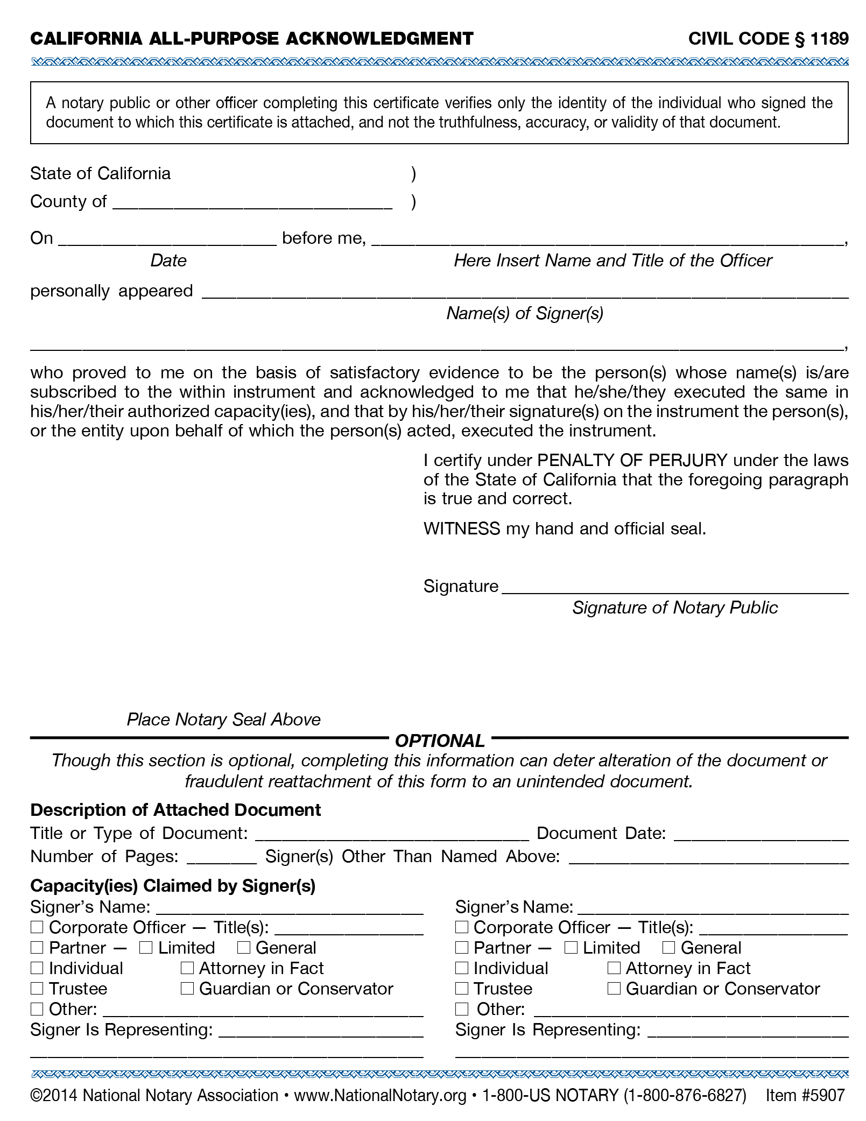

Tyrion:Users:MAN:Desktop:SGA:LA Housing:Letterhead:Round 2:Finals:LA_HCID_Letterhead_FINAL_Blank.pdf

**RECORDING REQUESTED BY:**

**AND WHEN RECORDED MAIL TO:**

CITY OF LOS ANGELES

HOUSING + COMMUNITY INVESTMENT DEPARTMENT

1200 WEST 7TH STREET, 8TH FLOOR

LOS ANGELES, CALIFORNIA 90017

ATTENTION: ENVIRONMENTAL AND LAND USE SERVICES UNIT

**ESCROW OR LOAN NO. TITLE ORDER NO. APN NO.**

**REQUEST FOR NOTICE**

UNDER SECTION 2924b CIVIL CODE

In accordance with section 2924B, Civil Code, request is hereby made that a copy of any Notice of Default and a copy of any Notice of Sale under the Deed of Trust recorded as Instrument

No\_\_\_\_\_\_\_\_\_\_\_\_\_\_\_\_\_\_ on Recording Concurrently \_\_\_\_\_\_\_\_\_\_, in book \_\_\_\_\_\_\_\_\_\_\_\_\_\_\_\_\_\_\_\_, page\_\_\_\_\_\_\_\_\_\_\_\_, Official Records of Los Angeles County, California, and describing land therein as

**SEE EXHIBIT A ATTACHED HERETO AND MADE A PART THEROF**

Common Property Address:\_\_\_\_\_\_\_\_\_\_\_\_\_\_\_\_\_\_\_\_\_\_\_\_\_\_\_\_\_\_\_\_\_\_\_\_\_\_\_\_\_\_\_\_\_\_\_\_\_\_\_\_\_\_\_

Executed by , as Trustor, in which is

named as Beneficiary, and , as

Trustee, be mailed to:

**City of Los Angeles, Housing + Community Investment Department,**

**1200 West 7th Street, 8th Floor,**

**Los Angeles, California 90017**

**Attention: Environmental and Land Use Services Unit**

NOTICE: A copy of any notice of default and of any notice of sale will be sent to the address contained in this recorded request. If your address changes, a new request must be recorded.

City of Los Angeles Housing + Community Investment Department

Signature By: \_\_\_\_\_\_\_\_\_\_\_\_\_\_\_\_\_\_\_\_\_\_\_\_\_\_\_\_\_\_\_\_\_\_\_\_\_\_\_\_\_\_\_\_\_\_ Dated:\_\_\_\_\_\_\_\_\_\_\_

Environmental Affairs Officer



Tyrion:Users:MAN:Desktop:SGA:LA Housing:Letterhead:Round 2:Finals:LA_HCID_Letterhead_FINAL_Blank.pdf

**RECORDING REQUESTED BY:**

**AND WHEN RECORDED MAIL TO:**

PV Home

Center Pointe Club

6200 Playa Vista Drive

PLAYA VISTA, CALIFORNIA 90094

ATTENTION: PV Home Administrator

**ESCROW OR LOAN NO. TITLE ORDER NO. APN NO.**

**REQUEST FOR NOTICE**

UNDER SECTION 2924b CIVIL CODE

In accordance with section 2924B, Civil Code, request is hereby made that a copy of any

Notice of Default and a copy of any Notice of Sale under the Deed of Trust recorded as Instrument No.\_\_\_\_\_\_\_\_\_\_\_\_\_\_\_\_ on \_\_\_\_\_\_\_\_\_\_\_\_\_\_\_ \_\_\_\_\_\_\_\_\_\_\_\_\_\_\_\_\_,

in book \_\_\_\_\_\_\_\_\_\_\_\_\_\_\_\_\_\_\_\_, page\_\_\_\_\_\_\_\_\_\_\_\_, Official Records of Los Angeles County, California, and describing land therein as

**SEE EXHIBIT A ATTACHED HERETO AND MADE A PART THEROF**

Common Property Address:\_\_\_\_\_\_\_\_\_\_\_\_\_\_\_\_\_\_\_\_\_\_\_\_\_\_\_\_\_\_\_\_\_\_\_\_\_\_\_\_\_\_\_\_ \_\_\_\_\_\_\_\_\_

Executed by \_\_\_\_\_\_\_\_\_\_\_\_\_\_\_\_\_\_\_\_\_\_\_\_\_\_\_\_\_\_\_\_\_\_\_\_\_\_\_\_\_\_\_\_\_\_\_\_\_\_\_\_\_\_\_\_\_\_\_\_\_\_\_\_\_\_, as Trustor, in which is

named as Beneficiary, and , as

Trustee, be mailed to:

**Playa Capital Company, LLC**

**6200 Playa Vista Drive,**

**Playa Vista, California 90094**

**Attn: PV Home Administrator**

NOTICE: A copy of any notice of default and of any notice of sale will be sent to the address contained in this recorded request. If your address changes, a new request must be recorded.

Playa Capital Company, LLC

Signature By: \_\_\_\_\_\_\_\_\_\_\_\_\_\_\_\_\_\_\_\_\_\_\_\_\_\_\_\_\_\_\_\_\_\_\_\_\_\_\_\_\_\_\_\_\_\_ DATED:\_\_\_\_\_\_\_\_\_\_\_



Tyrion:Users:MAN:Desktop:SGA:LA Housing:Letterhead:Round 2:Finals:LA_HCID_Letterhead_FINAL_Blank.pdf

**RECORDING REQUESTED BY:**

**AND WHEN RECORDED MAIL TO:**

PV Home

Center Pointe Club

6200 Playa Vista Drive

Playa Vista, CA 90094

Attention: PV Home Administrator

**ACKNOWLEDGMENT OF AGREEMENT**

DEFINITIONS

Controlled Price Units Agreement: Agreement Containing Covenants Affecting Real Property between the City of Los Angeles and Maguire Thomas Partners – Playa Vista First Phase of the Playa Vista Project

(Controlled Price Units)

Seller: \_\_\_\_\_\_\_\_\_\_\_\_\_\_\_\_\_\_\_\_\_\_\_\_\_\_\_\_\_\_\_\_\_\_\_\_\_\_\_\_\_\_\_\_\_\_\_\_\_\_\_\_\_\_\_\_\_\_\_\_\_\_\_\_\_\_\_\_\_\_\_\_\_\_\_\_\_

Buyer: \_\_\_\_\_\_\_\_\_\_\_\_\_\_\_\_\_\_\_\_\_\_\_\_\_\_\_\_\_\_\_\_\_\_\_\_\_\_\_\_\_\_\_\_\_\_\_\_\_\_\_\_\_\_\_\_\_\_\_\_\_\_\_\_\_\_\_\_\_\_\_\_\_\_\_\_\_

Controlled Price Unit (Insert Address of Unit):

\_\_\_\_\_\_\_\_\_\_\_\_\_\_\_\_\_\_\_\_\_\_\_\_\_\_\_\_\_\_\_\_\_\_\_\_\_\_\_\_\_\_\_\_\_\_\_\_\_\_\_\_\_\_\_\_\_\_\_\_\_\_\_\_\_\_\_\_\_\_\_\_\_\_\_\_\_,

as further described in Exhibit A attached hereto.

RECITALS

This Acknowledgment of Agreement is made this \_\_\_\_\_ day of \_\_\_\_\_\_\_\_\_\_\_\_, 20\_\_\_\_\_

A. Seller is the owner of that certain “Controlled Price Unit” (as that term is defined in the Controlled Price Units Agreement which is defined in Recital B below) which is legally described on Exhibit A attached hereto.

B. By the recordation of this Acknowledgment of Agreement, Buyer intends to ensure that title to the Controlled Price Unit is made subject to the provisions of the Controlled Price Units Agreement.

C. Pursuant to the Controlled Price Units Agreement, upon the recordation of the Controlled Price Units Agreement against the Controlled Price Unit, the covenants, conditions and restrictions contained therein shall run with the land and be binding upon MTP PV, MTP PV’s heirs, executors, administrators, successors, transferees, assignees, and all parties having or acquiring any right, title, or interest in or to any part of the Controlled Price Unit.

D. Since the execution of Exhibit B, Maguire Thomas Partners – Playa Vista has transferred all interests and responsibilities of the Controlled Price Units Agreements to Playa Capital Company, LLC and Playa Capital Company, LLC has transferred all interests and responsibilities to subsequent owners of such Controlled Price Unit.

ACKNOWLEDGMENT

NOW, THEREFORE, as a successor to Playa Capital Company, LLC’s interest in the property on which the Controlled Price Unit has been constructed, Buyer acknowledges that the covenants, conditions and restrictions contained in the Controlled Price Agreement run with the land and are binding upon heirs, executors, administrators, successors, transferees, assignees, and all other parties having or acquiring any right, title, or interest in or to any part of the Controlled Price Unit, except as otherwise provided in Section 2.5 of the Controlled Price Units Agreement. Any attempt to transfer title or any interest in the Controlled Price Unit in violation of the provisions of Article 2 of the Controlled Price Units Agreement shall be null and void.

IN WITNESS WHEREOF, Buyer has caused this Acknowledgment of Agreement to be executed as of the date first referenced above and Seller transfers such responsibility of the Controlled Price Units Agreement to Buyer.

BUYER: \_\_\_\_\_\_\_\_\_\_\_\_\_\_\_\_\_\_\_\_\_\_\_\_\_\_\_\_\_\_\_\_\_

\_\_\_\_\_\_\_\_\_\_\_\_\_\_\_\_\_\_\_\_\_\_\_\_\_\_\_\_\_\_\_\_\_

SELLER:\_\_\_\_\_\_\_\_\_\_\_\_\_\_\_\_\_\_\_\_\_\_\_\_\_\_\_\_\_\_\_\_\_

\_\_\_\_\_\_\_\_\_\_\_\_\_\_\_\_\_\_\_\_\_\_\_\_\_\_\_\_\_\_\_\_\_



